- Write a Program to print the alternative characters in a given String input?
- Write a Program to print the alternative vowels in a given string?
- Write a program to print the biggest / longest word in a given String?
- Write a Program to print the ASCII key values of a given String characters?
- Write a Program to print the index of a given character in a given string?
- Write a Program to print the last index of a given character in a given string?
- Write a Program to print the all the index’s of a given character in a given string?
- Write a Program to print the given input in lowercase and uppercase?
- Write a Program to print the string value from certain index to the end of the given String?
- Write a Program to print the String value from certain index to certain index of a given string?
- Write a Program to store the given String in character array and then print that character array?
- Write a Program to check the given character/String in a another given String?
- Write a Program to replace the all comma’s by space in a given string?
- Write a Program to replace the one word by another word in a given string?
- Write a Program to split the given String into individual words?
- Write a Program to understand the use of the trim method in strings?
- Write a Program to understand that where we have to use == and equals Method in strings?
- Write a Program to understand equalsIgnoreCase method in strings?
- Write a Program to check which is first word in dictionary order of given two words?
- Write a Program to check which is first word in dictionary order of given two words by ignoring Case?

Validations:-
- Write a Program to check/validate given String value is Valid Aadhar Number or not?
Input1: 439876875869
Ouput1:Valid Aadhar Number
Input2: 43@776875869
Ouput2:Not a Valid Aadhar Number
Input3: jtniv9t349nc
Ouput3:Not a Valid Aadhar Number
Input4: 1234 5678 9101
Ouput4:Valid Aadhar Number
Input5: 1234567890123412
Ouput5:Not a Valid Aadhar Number

- Write a Program to check/validate given String value is Valid Pan Number or Not?
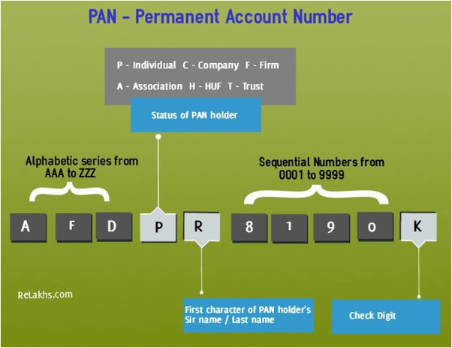

- Write a Program to check/validate given String value is Valid registration number or not of a Vehicle?
- Write a Program to check/validate given Password is perfect or not and the conditions are Password length must be 9 characters and must at least one capital, one small, one number and one special character (except space) ?

Searching:-
- Write a program to find the given word or a character is present or not in a given String?
- Write a program to find the index values of a given word in a given String?
- Write a program to find the numbers in a given String and print there index values?

Separation of categories:-
- Write a program to count the number of Special keys in a given String?
- Write a program to count the small letters in a given String?
- Write a program to print the all small characters, then print the capitals character, then print the Special characters and print the numbers in a given String?

Conversions(small<->Capitals):-
- Write a program to convert all small characters into capital characters and all capitals characters into small characters remaining characters don’t disturb any thing print Directly?
- Write a program to convert all small characters into capital characters and all capitals characters into small characters of alternative places?

Reverse of a String:-
- Write a program to print the reverse of a given word ?
- Write a program to print the all given words in reverse without changing words positions?
Input: to print the all given words
Output: ot tnirp eht lla nevig sdrow
- Write a program to print the given String in reverse?
- Write a program to find the given String is Palindrome or not?

Frequency / occurrence / Duplicates:-
- Write a program to find the count of a each and every word in a given String?
- Write a program to find the count of a each and every character in a given String?
- Write a program to print most repeated character and word in a given String?
- Write a program to print the words in given string to the count(Repetation) in decreasing order?
- Write a program to print the unique words in a given string?
- Write a program to print the smallest Unique word in a given String?
- Write a program to print the largest Unique word in a given String
- Write a program to print the words and count of the duplicate words in a given String?

subStrings:-
- Write a program to print the all substrings in a given string?
Input: java
Output: j, ja, jav, java, a, av, ava, v, va, a
- Write a program to find the given substring is there are not in a given String?

Sortings:-
- Write a program to print the all words in decreasing order(word size) of a Given String?
- Write a program to sort the words in a given String according to alphabetically (lexigrophically)?
- Write a program to print the “N” number of time repeated word in a given string?
- Write a program to print all characters in alphabetical order in a given string with repetition?

Use Cases:-
- Write a Program to print the common words in a given two Strings?
- Write a Program to print the common Unique words in a given two Strings?
- Write a Program to print all the words in a given two Strings by one time only?
- Write a Program to print all the words in a given two Strings in sorted order?
- Write a Program to print to the given String as three characters in each line?
- Write a Program to print to the given String characters as shown in example?
Ex:- Input:- I am preparing myself for MNC’s and Product based companies.
Output:- I
am
pre
pari
ngmys
elffor
MNC’san
dProduct
basedcomp
anies.

